NAME: Mahmoud moustafa mahmoud moustafa

B.N: 868

DATE:

TOPIC: programming languages

GITHUB LINK :

GITHUB PAGE (published-website) :

APPLICATION PRIEF:

Computer-Programming Language is a language with specific rules and frameworks that can be used to write programs and applications running on computers, leading to the implementation of a specific algorithm that will lead to the achievement of an output. When we say that the programming language is a grammar language, this means something quite similar to the spoken human languages, i.e. the programming language has certain limitations that must be followed while writing with it, and not following these rules will lead to the formation of grammatically incorrect programming lines, which is called the world of programming with a text error Syntax Error. Likewise also for spoken human languages, we can write grammatically correct script but it does not lead to any beneficial result, and this makes it semantic meaningless, and so, writing programs using one of the programming languages requires observing the rules to produce a correct syntax text with meaningful Semantic Meaningful.

SCREEN SHOTS:

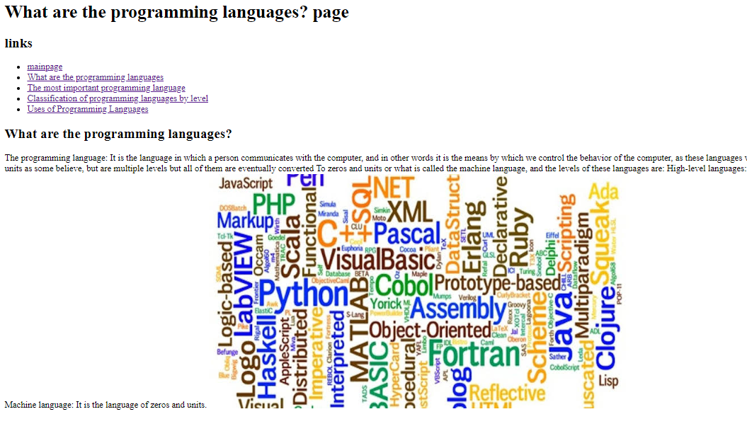

SOURCE CODE:

